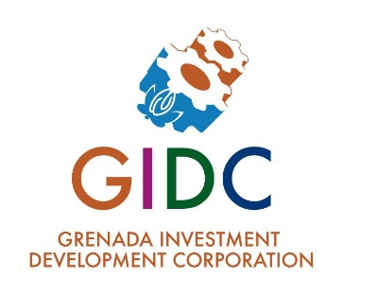GRENADA INVESTMENT DEVELOPMENT CORPORATION

REQUEST FOR PROPOSAL

**APPRAISAL OF GIDC’S PROPERTIES**

**Procuring Entity**: Grenada Investment Development Corporation

**Address:** Building #7 Frequente Business Park

**Description of**

**Services:** The Grenada Investment Development Corporation is seeking Proposals from qualified individuals, businesses, or corporations to inspect its properties located at Frequente, Simon and St. Patrick to provide a quotation to appraise said properties.

Persons responding to this RFP should poses the following qualifications;

a) Valuation of properties 15 years’ experience

b) Commercial Valuation of properties 10 years’ Experience

c) At Least a Bachelors’ Degree in; Architecture, Civil Engineering, Quantity Surveying, Real Estate Management, Property Development and Valuation, Construction Management

**Procurement**

**Method:** Open Competitive Tendering

**Contact Person:** Chief Executive Officer – Grenada Investment Development Corporation

Tel: 444-1033; email: [propertyappraisal@gidc.gd](mailto:propertyappraisal@gidc.gd)

**Proposal Document**

**Available at:** The Office of The Grenada Investment Development Corporation or via email request.

**Deadline for**

**Receiving Proposals: May 20, 2025** at 3:00pm

**Opening Date of**

**Proposals: May 20, 2025** at 3:15pm

**Additional information**

Unsealed proposals or proposals delivered after the deadline for submission will not be accepted.

The Grenada Investment Development Corporation is not obligated to accept the lowest or any tender.

The Grenada Investment Development Corporation may, at any time, terminate this procurement proceedings without entering into a contract.

Tenderers, or their representatives, may attend the opening session.